Clean up your dental routine with the new range of Panasonic Oral Irrigators

Get top class care with Ultrasonic technology for powerful yet gentle cleaning, as proven by experts

[](https://www.youtube.com/@PanasonicEuropeYouTubeChannel)

[](https://twitter.com/PanasonicEurope)[](https://www.panasonic.com/)[](https://www.facebook.com/people/Panasonic-Europe/61552183186987/)

September 2024



* To get optimal results from your oral care routine, brushing alone isn’t always enough
* Panasonic have introduced a brand-new range of Oral Irrigators, with Ultrasonic technology clinically tested by dentists
* Using an irrigator with ultrasonic technology on a daily basis can result in heathier gums in just one week[1]

**Why choose a Panasonic Oral Irrigator?**

Taking proper care of your teeth and gums can help prevent Periodontitis, or periodontal disease, an infection of the tissue – known as gingiva – that holds the teeth in place. When brushing and dental floss aren’t effective, bacteria can harden and stimulate chronic inflammation which attacks the gums and bone that supports the teeth. This can lead to pain and bleeding gums, chewing pain, tooth loss and more.[2]

In fact, periodontitis is the most common disease in Europe, with 8 out of 10 people aged 35 and older suffering from some kind of gum issues.[3]

By adding a Panasonic Oral Irrigator to your routine, you can clean all areas of the teeth more thoroughly, especially the harder to reach areas, which in turn helps reduce the risk of periodontal disease.

Panasonic Ultrasonic Oral Irrigators have undergone a clinical study to put them to the test, by leading inspection company, SGS proderm in Germany, who work with professional dentists.

The study revealed that participants found that they had healthier gums after just one week[4] of using a Panasonic Ultrasonic Oral Irrigator, and that daily use proved up to two times more effective for healthy gums than string floss[5]

By adding a Panasonic Oral Irrigator to your daily routine you can put your mind at ease, knowing that you’re providing yourself with the best possible oral hygiene, helping to brighten your smile and boost your confidence.

**Protect teeth and strength gums with Ultrasonic Technology**

The latest irrigators in the Panasonic oral care range, the Series 800, Series 600 and Series 300, are designed to help you achieve your best oral health yet.

An upgrade from your standard water flosser, the Series 800 and 600 models come equipped with Ultrasonic technology to boost cleaning performance and leave teeth feeling fresh and healthy. Their patented nozzles and special water pumps combine to generate powerful bubbles that burst onto teeth, amplifying the cleaning power to all areas of the mouth - even around orthodontic appliances where debris and plaque can otherwise easily build up.

In addition to removing food debris from the surface of the teeth, the powerful Ultrasonic water jet can easily clean areas between the teeth, as well as periodontal pockets, to help prevent tooth decay and gum disease.

The design of the Panasonic irrigators also means that the sensation whilst cleaning is gentle, unlike traditional flossing, so you can clean your gums without causing irritation.

**Proven to Remove Up to 99.9 % Plaque from Treated Areas[6]**

Often, you may think you have thoroughly cleaned your teeth, however about 50% of plaque remain after cleaning with just your toothbrush alone[7]. Therefore, irrigators are important for a complete and effective hygiene routine, as they’re able to remove food debris and plaque simply and effectively, even in interdental areas that are very difficult to reach.

**Adaptable to you**

Both the Series 800 and 600 models allow you to specifically tailor your oral care routine, with five different water pressure levels, meaning you can find the perfect fit to give you a comfortable clean. Plus, once you’ve found your ideal setting, your device will remember and use it as a default. Depending on your chosen model, the Panasonic irrigators also come equipped with separate nozzles for specific uses: the Ultrasonic Nozzle that uses the water jet for cleaning, or an Orthodontic Nozzle with bristles for assisting users with orthodontic appliances such as braces and a Tongue Care Nozzle.

**Easy to Use**

Incorporating a Panasonic irrigator into your daily routine is simple, as it only takes around one minute to effectively clean all your teeth.

In fact, 90% of those tested agreed that a Panasonic Ultrasonic Irrigator provides easy and effective cleaning between the teeth and areas difficult to reach with a toothbrush or string floss[8].

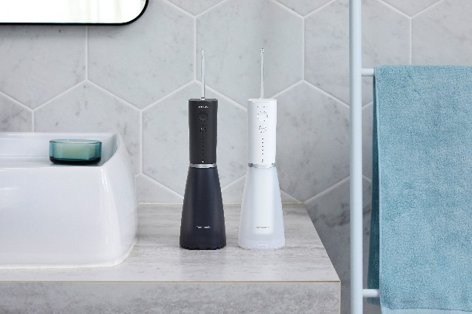**Series 800**

The Series 800 model EW-DJ86 features clinically tested, advanced Ultrasonic technology, that helps achieve healthier gums in just one week[9].

Equipped with two different types of nozzles, one Ultrasonic nozzle and one Orthodontic nozzle, the EW-DJ86 is also quick and easy to charge, with a one-hour USB (type C) charge time, making it ideal for travel.

Depending on country the EW-DJ86 is available in Black and White.

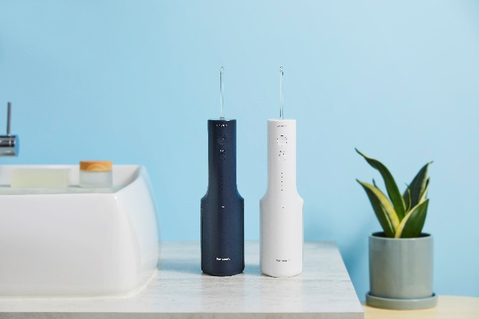**Series 600**

The Series 600 models, EW-DJ67 and EW-DJ66, also feature clinically tested, advanced Ultrasonic technology that provides healthier gums in just one week[10], and are equipped with dedicated compact charging stands and dishwasher safe water tanks.

The EW-DJ66 comes with two Ultrasonic nozzles and is available in Navy and White depending on country.

The EW-DJ67 comes with one Ultrasonic, one Orthodontic and one Tongue Care Nozzle, for total effective cleaning of all areas, and is available in White.

**Series 300**

The Series 300 models provide easy and effective cleaning, with dedicated charging stands and dishwasher safe water tanks.

The Series is comprised of the model EW-DJ26, that comes with two standard nozzles, or the model EW-DJ27, equipped with four standard nozzles, both of which are available in the colours Baby Blue and Light Violet, depending on country.

**About the Panasonic Group**

Founded in 1918, and today a global leader in developing innovative technologies and solutions for wide-ranging applications in the consumer electronics, housing, automotive, industry, communications, and energy sectors worldwide, the Panasonic Group switched to an operating company system on April 1, 2022 with Panasonic Holdings Corporation serving as a holding company and eight companies positioned under its umbrella. The Group reported consolidated net sales of Euro 54.12 billion (8,496.4 billion yen) for the year ended March 31, 2024. To learn more about the Panasonic Group, please visit : <https://holdings.panasonic/global/>.

**Create Today. Enrich Tomorrow.**

Holistic Wellbeing for People, Society, and the Planet - Our goal is to bring balance to People, Society and the Planet through our innovative solutions & products; promoting overall wellbeing for everyone by creating a healthier, simpler and more balanced way of living.

[Find out more >](https://www.panasonic.com/uk/consumer/create-today-enrich-tomorrow/holistic-wellbeing/social-wellbeing.html)

**Panasonic Group Environmental Initiatives**

The Panasonic Group has set forth its long-term environmental vision, "Panasonic GREEN IMPACT," with the aim of achieving both a better life and a sustainable global environment for all. Under PGI, Panasonic Group strives towards achieving virtually net zero CO2 emissions from its own operations by 2030, and aims to create an impact of more than 300 million tons (*1) of reduced and avoided CO2, which is equivalent to about 1 percent of the current global total of approximately 31.7 billion tons (*2) by 2050. The group also works on business activities to realize a circular economy in which resource efficiency contributes to decarbonization and reduces the consumption of limited natural resources.

*1: CO2 Emission factor based on 2020

*2: 31.7 billion tons of energy-derived CO 2 emissions in 2020 (Source: IEA)

[Panasonic GREEN IMPACT - About Us - Panasonic Holdings](https://holdings.panasonic/global/corporate/panasonic-green-impact.html)

1. Gum bleeding and Gingival index measured at 1 week after daily use of manual toothbrush and the Panasonic Ultrasonic Irrigator at level 4-5 compared to baseline, SGS proderm, Germany 2023
2. National Institute of Dental and Craniofacial Research, USA, “Health Info, Gum Disease, Periodontal (Gum) Disease”, https://www.nidcr.nih.gov/health-info/gum-disease/more-info, accessed on 2021-09-15
3. European Federation of Periodontology, “Dossier on Periodontal Disease”, 2020 Edition, Page 4 of 16, https://www.efp.org/fileadmin/uploads/efp/Documents/Campaigns/Gum_health_day/Publications/EFP_Dossier_on_Periodontal_Disease_2020.pdf, accessed on 2021-09-15
4. Gum bleeding and Gingival index measured at 1 week after daily use of manual toothbrush and the Panasonic Ultrasonic Irrigator at level 4-5 compared to baseline, SGS proderm, Germany 2023.
5. Gingival index measured at 4 weeks after daily use of manual toothbrush and the Panasonic Ultrasonic Irrigator at level 4-5 compared to daily use of manual toothbrush and string floss, SGS proderm, Germany 2023.
6. 1 Laboratory test, China 2023.
7. 2 S. The role of manual toothbrushes in effective plaque control, advantages and limitations. In: Lang NP, Attstrom R, Loe H, eds. Proceedings of the European Workshop on Mechanical Plaque Control. Chicago: Quintessence Publishing Co., 1998:121-137.
8. Panel test with Panasonic Ultrasonic Irrigator after 4 weeks of daily use, n=31, SGS proderm, Germany 2023.
9. Gum bleeding and Gingival index measured at 1 week after daily use of manual toothbrush and the Panasonic Ultrasonic Irrigator at level 4-5 compared to baseline, SGS proderm, Germany 2023.
10. Gum bleeding and Gingival index measured at 1 week after daily use of manual toothbrush and the Panasonic Ultrasonic Irrigator at level 4-5 compared to baseline, SGS proderm, Germany 2023.