**Panasonic Announces New LUMIX GH7 Micro Four-Thirds Mirrorless Camera**

Panasonic is proud to introduce the new LUMIX GH7 - the latest flagship model of the Micro Four Thirds mirrorless LUMIX G Series.

[](https://www.youtube.com/@PanasonicLumixVideo)[](https://www.instagram.com/lumix/)[](https://www.facebook.com/LumixEurope/)[](https://www.panasonic.com/global/consumer/lumix.html)

Wiesbaden, 5th June 2024

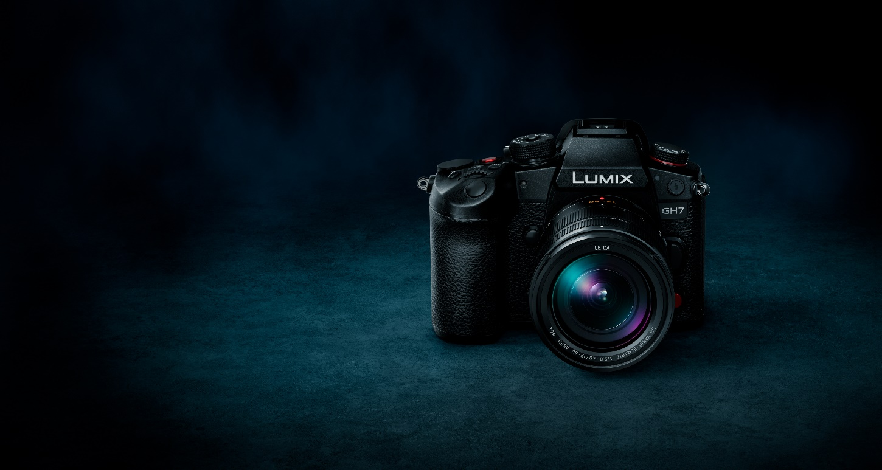

The LUMIX GH7 delivers outstanding video performance, wide dynamic range with a newly developed 25.2MP BSI CMOS sensor, and improved AF performance with PDAF (Phase Detection Auto-Focus). To support the efficient workflow required in professional production environments, the GH7 is newly equipped with Apple ProRes RAW*1 internal recording and the World’s first 32-bit float recording*2, which eliminates the need to adjust sound recording levels during shooting.

With the rapid increase in demand for video content in recent years, the number of small teams of video creators is rising, along with the demand for further improvements in the quality of mirrorless cameras with excellent video performance and portability. Since its release in 2009, our LUMIX GH series has developed a strong reputation among creators and video production teams as a model renowned for its shooting performance, innovative features and reliability.

The LUMIX GH7 is a next-generation mirrorless camera that meets the needs of creators, whatever their creative field may be.

**High performance, fast response, and excellent mobility**

* 25.2MP BSI CMOS sensor with high resolution and fast response, along with 13+ stop dynamic range boost*3 with rich gradation
* Adopting PDAF for high-speed, high-precision AF performance, and newly added real-time auto-focus recognition AF for airplanes and trains
* Improved image stabilization technology, including perspective distortion correction for videos and High mode in Active I.S. to enable powerful compensation when shooting on the move

**Enhanced video quality and optimized workflows from shooting to post-production**

* Internal recording of 5.7K 30p ProRes 422 HQ and ProRes RAW HQ*1.
* World’s first 32-bit float recording*2, eliminating the need to adjust audio recording levels during shooting when using the new XLR microphone adapter, DMW-XLR2 (sold separately).
* Allows users to load original LUT files and apply new color looks directly to videos and photos with REAL TIME LUT.
* Enables proxy recording for workflow efficiency and supports native Camera to Cloud integration with Adobe’s Frame.io, enabling images and videos to be automatically uploaded, backed up, shared, and worked on jointly via the cloud.
* Open Gate recording to enable flexible framing for any social media platform or client needs.

**Reliable in the video production field**

* Unlimited video recording made possible with efficient heat dissipation processing and the integration of a cooling fan*4.
* Convenient tilt-free angle monitor that does not interfere with HDMI or USB cables when tilted
* Able to withstand harsh environments with dust, splash resistance*5, and freeze-resistance down to -10 degrees Celsius/14 degrees Fahrenheit.

*1 Recording is not possible on the SD card.

*2 For an interchangeable lens digital camera, as of June 5th 2024. According to Panasonic's research. When used with the XLR microphone adapter DMW-XLR2 (sold separately).

*3 Dynamic Range Boost is not activated when shooting HFR/VFR video of 61fps or higher, or with SH burst shooting. Also not activated at shutter speeds slower than 1/15 during still image shooting, depending on the ISO. When shooting video over 60 fps (including VFR), latitude will be 12+ stop.

*4 When shooting at C4K/60p or lower. There are temperature restrictions for resolutions exceeding Cinema4K, VFR/HFR, and ProRes. Recording time depends on battery and memory card capacity.

*5 Dust and Splash Resistant does not guarantee that damage will not occur if this lens is subjected to direct contact with dust and water.

Apple and ProRes are trademarks or registered trademarks of Apple Inc. in the United States and/or other countries.

Frame.io, the Frame.io logo, and Camera to Cloud are either registered trademarks or trademarks of Adobe in the United States and/or other countries.

Other trademarks and trade names are those of their respective owners.

All functions may not be available depending on the situation.

Design and specifications are subject to change without notice.

**About the Panasonic Group**

Founded in 1918, and today a global leader in developing innovative technologies and solutions for wide-ranging applications in the consumer electronics, housing, automotive, industry, communications, and energy sectors worldwide, the Panasonic Group switched to an operating company system on April 1, 2022 with Panasonic Holdings Corporation serving as a holding company and eight companies positioned under its umbrella. The Group reported consolidated net sales of Euro 54.12 billion (8,496.4 billion yen) for the year ended March 31, 2024. To learn more about the Panasonic Group, please visit: <https://holdings.panasonic/global/.>

**Motion. Picture. Perfect.**

Created in 2001, LUMIX boldly incorporated technology that was the first of its kind. Since then, we have released many innovative LUMIX products worldwide, leading the industry in mirrorless cameras. In making LUMIX, we have ceaselessly pursued ever higher levels of technical and creative innovation. Our cameras’ formidable photographic and cinematic quality combines a rich creative expressiveness with intuitive, easy-to-use features and hard-working reliability to capture fleeting moments with ease and precision. Our commitment to meeting the needs and wants of creators drives us to create the finest instruments for making works of art.