**Panasonic Announces New LUMIX S9 Compact Full-Frame Mirrorless Camera**

* Smallest and lightest LUMIX S Series camera*1 with stylish compact design in multiple color variations
* Outstanding imaging performance with approx. 24.2MP full-frame sensor
* Shoot and share to social media in 30 seconds*2 with the new LUMIX Lab app

[](https://www.instagram.com/lumix/)[](https://www.youtube.com/@PanasonicLumixVideo)[](https://www.facebook.com/LumixEurope/)[](https://www.panasonic.com/global/consumer/lumix.html)

Wiesbaden, 22nd May 2024

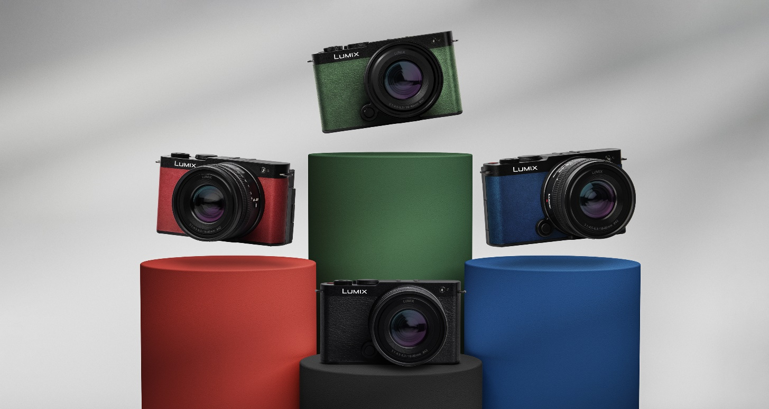

Panasonic is proud to announce the LUMIX S9, the smallest and lightest full-frame mirrorless camera in the LUMIX S Series. Available in a choice of colors – Jet Black, Crimson Red, Dark Olive, and Classical Blue – the LUMIX S9 is a stylish companion for content creators on the go.

The approx.24.2-megapixel full-frame CMOS sensor, equivalent to that of the LUMIX S5II, and the latest engine capture content in rich detail with natural tones. In addition, the camera is equipped with PDAF (Phase Detection Auto-Focus), which provides excellent subject tracking, and Active I.S., which significantly reduces blurring from camera shake even when shooting handheld, allowing users to shoot confidently, whatever the situation.

The LUMIX S9 also allows creators to easily enjoy a range of popular, classic or bespoke color styles in-camera with the popular REAL TIME LUT function via a new dedicated ‘LUT’ button on the camera body.

In addition, the new LUMIX Lab app enables creators to develop their own unique LUT color files on their smartphone. This means users can effortlessly generate original and shareable stills and videos without the need of post-production editing on a computer, expanding the scope of creative possibilities. The speed of transferring data from camera to smartphone has also been improved with the new app.

The LUMIX S9 introduces a new recording format; MP4 Lite. Shooting Open Gate in 4:2:0 10 bit in 30p/25p, creators can capture high quality videos in the optimum format for smartphone, and easily resize aspect ratios to suit social media with the LUMIX Lab app. With this new streamlined editing workflow, content creators can easily shoot and share while on the go.

Panasonic aims to offer a new enjoyable shooting experience to creators with the LUMIX S9, making the journey from capturing the moment to sharing with the world seamless and intuitive.

**The first compact design in the LUMIX S Series, combining a small and lightweight body with high image quality**

* Compact and lightweight body weighing approximately 403g/0.89 lb*3
* Approx. 24.2-megapixel full-frame CMOS sensor and the latest engine deliver powerful imaging performance.
* Improved real-time recognition AF with PDAF (Phase Detection Auto-Focus) for more precise subject tracking performance.
* Industry leading image stabilization technology with 5-axis Dual I.S.2: 6.5 stops*4 / Body I.S.: 5 stops*5 and Active I.S. compensate for camera shake when shooting while walking. With perspective distortion correction and High mode in the E-Stabilization (Video) function, it is now possible to achieve even more stable footage when shooting on the move.
* Equipped with MP4 Lite, a new smartphone-optimized Open Gate video mode
* Free-angle rear screen for flexible shooting at all angles

**New LUMIX Lab app for effortless connection**

* Allows high-speed transfer of photos and videos from the camera to a smartphone.
* Enables users to easily create original LUT files and transfer them from a smartphone to the camera, allowing them to enjoy their own preferred color expressions.
* LUTs from popular creators are also available to download and use from the app
* Quick and easy editing of MP4 Lite video files optimized for social media sharing

**REAL TIME LUT for a wider range of creative expression**

* Fully customizable LUT color files can be loaded in-camera for creative shooting
* Dedicated LUT button on the camera body for direct access to LUT settings
* Added opacity control and grain effect to further enhance creativity
* Up to 2 LUT files can be applied at the same time

*1 Within LUMIX S series line up, as of May 22nd, 2024.

*2 The total time it takes to transfer a JPEG photo or a 5-second short video shot in MP4 (Lite) mode to an iOS-supported smartphone using the LUMIX LAB app, including cropping in case of video, and posting to social media. Study conducted under Panasonic standards. Results may vary depending on network environment.

*3 Body and shoe cover. Excluding the body cap. The combined weight of the body, shoe cover, battery, and SD memory card is approximately 486g/1.08 lb.

*4 Based on the CIPA standard [Yaw/Pitch direction: focusing distance f=200mm] when S-E70200 is used.

*5 Based on the CIPA standard [Yaw/Pitch direction: focusing distance f=60mm] when S-R2060 is used.

**About the Panasonic Group**

Founded in 1918, and today a global leader in developing innovative technologies and solutions for wide-ranging applications in the consumer electronics, housing, automotive, industry, communications, and energy sectors worldwide, the Panasonic Group switched to an operating company system on April 1, 2022 with Panasonic Holdings Corporation serving as a holding company and eight companies positioned under its umbrella. The Group reported consolidated net sales of Euro 54.12 billion (8,496.4 billion yen) for the year ended March 31, 2024. To learn more about the Panasonic Group, please visit: <https://holdings.panasonic/global/.>

**Motion. Picture. Perfect.**

Created in 2001, LUMIX boldly incorporated technology that was the first of its kind. Since then, we have released many innovative LUMIX products worldwide, leading the industry in mirrorless cameras. In making LUMIX, we have ceaselessly pursued ever higher levels of technical and creative innovation. Our cameras’ formidable photographic and cinematic quality combines a rich creative expressiveness with intuitive, easy-to-use features and hard-working reliability to capture fleeting moments with ease and precision. Our commitment to meeting the needs and wants of creators drives us to create the finest instruments for making works of art.