**Panasonic Introduces New LUMIX S Series Fixed Focal Length Pancake Lens: LUMIX S 26mm F8 (S-R26)**

[](https://www.instagram.com/lumix/)[](https://www.youtube.com/@PanasonicLumixVideo)[](https://www.facebook.com/LumixEurope/)[](https://www.panasonic.com/global/consumer/lumix.html)

Wiesbaden, 22nd May 2024

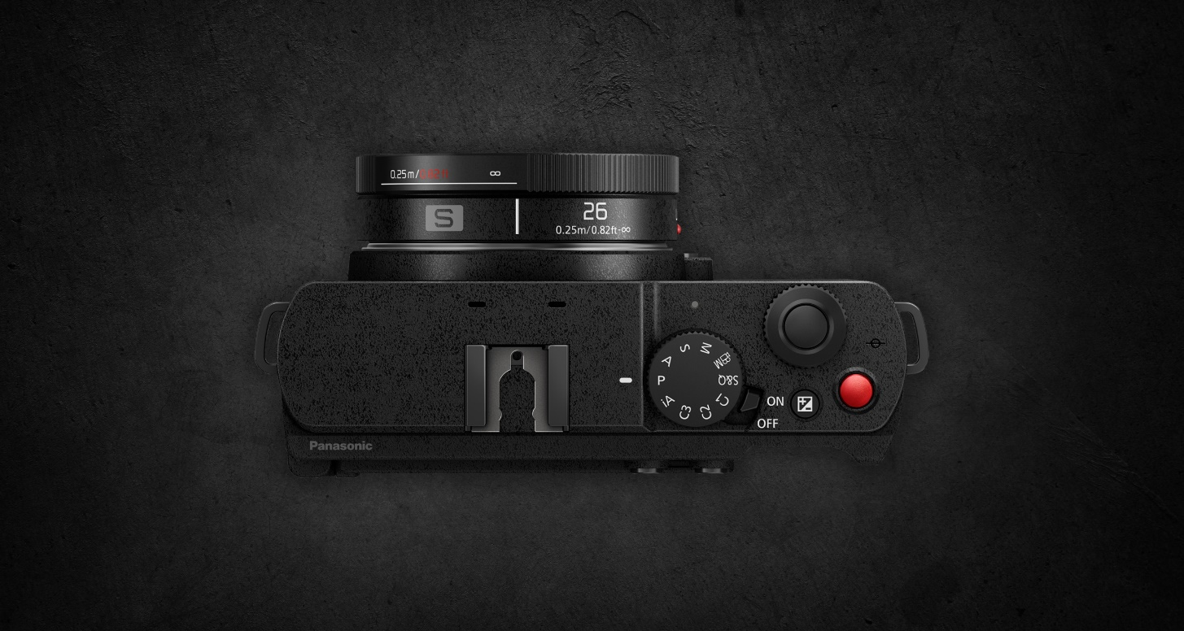

Panasonic is pleased to announce the new LUMIX S 26mm F8 (S-R26), an incredibly compact and lightweight full frame lens. The slim design enhances portability, without compromising on high resolution and outstanding image quality.

With a fixed focal length of 26mm, F-stop of F8, and manual focus, this new pancake lens is designed for the enjoyment of casual and creative shooting. Perfect for spontaneously capturing fleeting moments, the 26mm delivers unique results compared to the existing line-up of LUMIX S Series wide-angle, fixed focal length lenses.

**A new fixed focal length pancake lens in the LUMIX S Series**

* Manual focus allows creators to take full control of their own personal style of content creation
* The lens has a wide angle of 26mm and a fixed F-stop of F8

**Compact, lightweight lens perfect for everyday**

* Ultimate portability with a thin and lightweight body that fits into your pocket
* Easy to carry around and start shooting at a moment’s notice, making it ideal for spontaneous snapshots
* Overall length of approximately 18.1mm and a weight of approximately 58g/0.13lb.

･ This lens is for manual focus only, fixed at F8. The camera's AF setting, and some MF assist functions cannot be used.

･ External filters cannot be attached.

･ L-Mount is a trademark or registered trademark of Leica Camera AG.

**Coming Soon:**

**A new compact wide zoom lens: LUMIX S 18-40mm F4.5-6.3**

A new LUMIX S 18-40mm F4.5-6.3 lens is coming to the full frame LUMIX S Series lens line-up soon. A compact and versatile zoom lens ideal for daily use, the upcoming 18-40mm has a closest shooting distance of 0.15m/0.49ft. This lens covers focal lengths from an ultra-wide angle of 18mm to a semi-standard 40mm, allowing for the flexibility to capture expansive landscapes and buildings or portrait shots in a natural perspective.

･ Design and specifications are subject to change without notice

**About the Panasonic Group**

Founded in 1918, and today a global leader in developing innovative technologies and solutions for wide-ranging applications in the consumer electronics, housing, automotive, industry, communications, and energy sectors worldwide, the Panasonic Group switched to an operating company system on April 1, 2022 with Panasonic Holdings Corporation serving as a holding company and eight companies positioned under its umbrella. The Group reported consolidated net sales of Euro 54.12 billion (8,496.4 billion yen) for the year ended March 31, 2024. To learn more about the Panasonic Group, please visit: <https://holdings.panasonic/global/.>

**Motion. Picture. Perfect.**

Created in 2001, LUMIX boldly incorporated technology that was the first of its kind. Since then, we have released many innovative LUMIX products worldwide, leading the industry in mirrorless cameras. In making LUMIX, we have ceaselessly pursued ever higher levels of technical and creative innovation. Our cameras’ formidable photographic and cinematic quality combines a rich creative expressiveness with intuitive, easy-to-use features and hard-working reliability to capture fleeting moments with ease and precision. Our commitment to meeting the needs and wants of creators drives us to create the finest instruments for making works of art.