**PANASONIC SERIES 700 WET/DRY SHAVER**

**Japanese technology and clean design without any fuss**

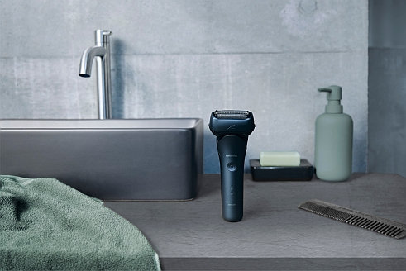

What do you get when you combine the linear motor and beard density sensor of the current Panasonic high-end shaver with a 3-blade cutting system? The answer is the **Panasonic Series 700** with a minimalist design. The wet/dry shaver is the ideal essential for those who know what they want: strong technology without any fuss and at a good price.

The Panasonic Series 700 gets the day off to an uncomplicated start. Dry, or preferably wet with foam or gel? The Panasonic shaver offers multiple options. It can quickly turn liquid soap into a fine foam in the absence of regular shaving foam.

For a thorough, skin-friendly shave, the ES-LT4B combines some of Panasonic’s best shaver technologies. The heart of the Series 700 is its ultra-fast linear motor, which is also used in the latest Panasonic Premium shavers. It powers the 3-blade system, with magnetic levitation technology, with a total of 39,000 cutting movements per minute. As a result, daily shaving is not only done in just a few strokes, it is also particularly gentle on the skin.

The Series 700 shaving head features two finishing foil shavers for even closer shaves and an integral cutter for strong, unruly beard hair on the chin and neck. All three blades are manufactured using Panasonic’s advanced Japanese blade technology, which is considered to be particularly sharp, strong and durable. They are nano-polished at an angle of only 30 degrees and effortlessly cut even strong beard stubble. The foil shavers are also made from this premium material and allow a particularly close shave – for less beard shadow, even in the late afternoon.

In addition to the power of the Panasonic linear motor and the sharpness of the Japanese blades, the Series 700 offers reliable contour adjustment. The laterally tilting shaving head gives the user plenty of control over the shaver, while the floating blades adapt to the contour of the face.

Because every beard is different, the Series 700 is equipped with Panasonic’s most responsive beard density sensor. It determines beard density and thickness 216 times a second and adjusts the motor power accordingly. This makes every shave as unique as the face to be shaved.

The Series 700, alias Panasonic ES-LT4B, also features a hinged trimmer. With its also nano-polished blade (45 degrees), it ensures clean contours and clear edges along sideburns.

**Li-ion power, quick charge and quick cleaning**

Incidentally, whether the lithium-ion battery is fleshly charged or almost empty plays no rule in the performance of the Panasonic Series 700. Its linear motor always delivers constant power regardless of the charge level.

An LED display in the grip of the simple and attractive shaver reminds you to charge in time. Those who forget will still be able to get out of the house on time and fleshly shaved thanks to the quick charge function. Just three minutes of charging time is enough for three minutes of power. The entire charging process for 45 minutes of operation is completed in one hour.

The Panasonic Series 700 is also wonderfully straightforward when it comes to gadget maintenance. The ES-LT4B is waterproof and can be easily cleaned under the tap. The jet of water flows through a small cover on the front of the shaving head, taking the beard stubble with it.

A fingertip-activated travel lock ensures that the wet/dry shaver does not accidentally switch on while on the move.

**Availability**

High-quality, matt materials and a rubberized grip make the Panasonic ES-LT4B an attractive, safe-to-use essential for men’s care.

From August 2023, the Panasonic Series 700 will be available in Deep Blue (ES‑LT4B‑A).

**About the Panasonic Group**

Founded in 1918, and today a global leader in developing innovative technologies and solutions for wide-ranging applications in the consumer electronics, housing, automotive, industry, communications, and energy sectors worldwide, the Panasonic Group switched to an operating company system on April 1, 2022 with Panasonic Holdings Corporation serving as a holding company and eight companies positioned under its umbrella. The Group reported consolidated net sales of 8,378.9 billion yen (ca. 59.4 billion Euro) for the year ended March 31, 2023. To learn more about the Panasonic Group, please visit: <https://holdings.panasonic/global/>